表格 1

|  |  |  |  |  |
| --- | --- | --- | --- | --- |
|  | BP | LSTM | EEMD-BP | EEMD-LSTM |
| RMSE |  |  |  | 0.0211 |
| MAE |  |  |  | 0.0143 |
| MAPE |  |  |  | 3.3295 |
| R2 |  |  |  | 0.9858 |

表格 2

|  |  |  |  |  |
| --- | --- | --- | --- | --- |
|  | RMSE | MAE | MAPE | R2 |
| EEMD-LSTM | 0.0211 | 0.0143 | 3.3295 | 0.9858 |
| EEMD-BP | 0.0242 | 0.0188 | 4.6163 | 0.9807 |
| LSTM | 0.0403 | 0.0276 | 6.4849 | 0.9464 |
| BP | 0.0401 | 0.0284 | 6.7019 | 0.9468 |

LSTM

RMSE:0.0403

MAE:0.0276

MAPE:6.4849

R2:0.9464

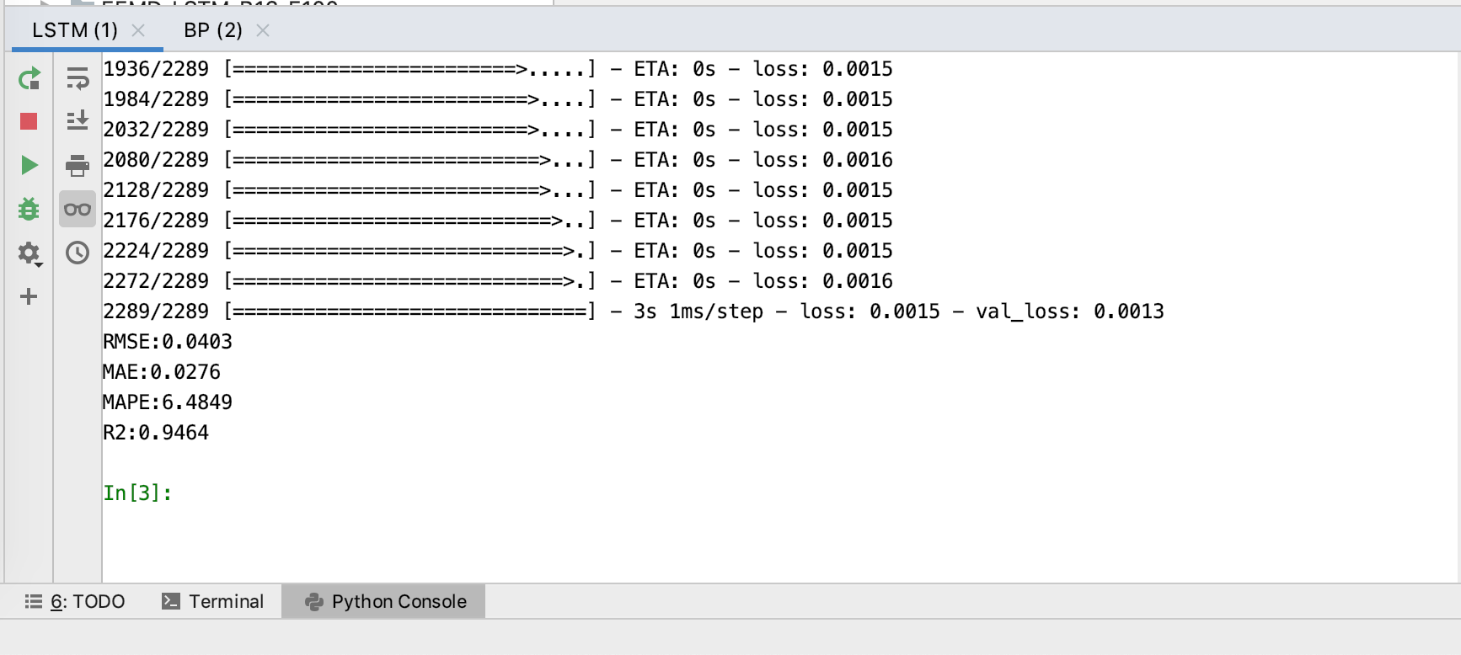

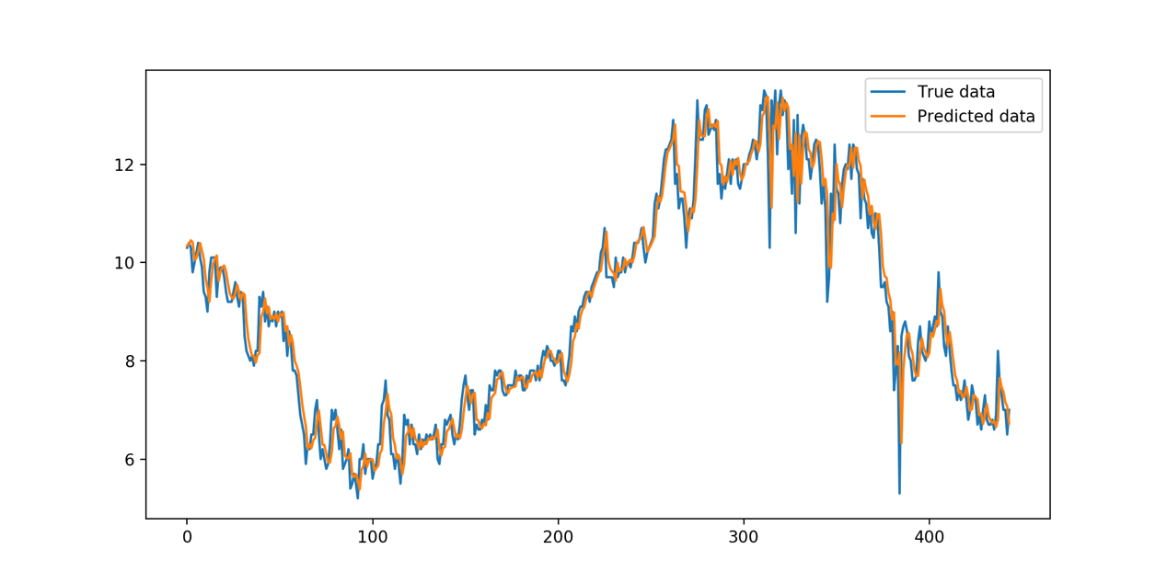

BP

RMSE:0.0401

MAE:0.0284

MAPE:6.7019

R2:0.9468

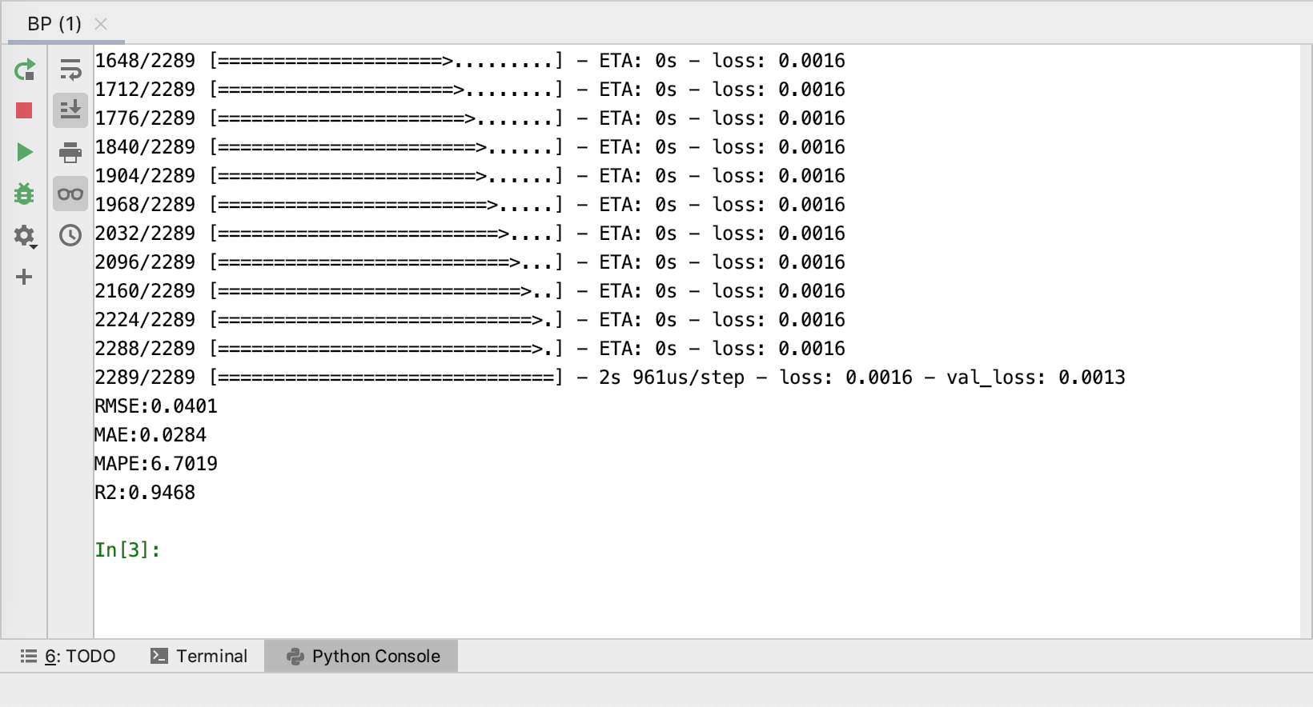

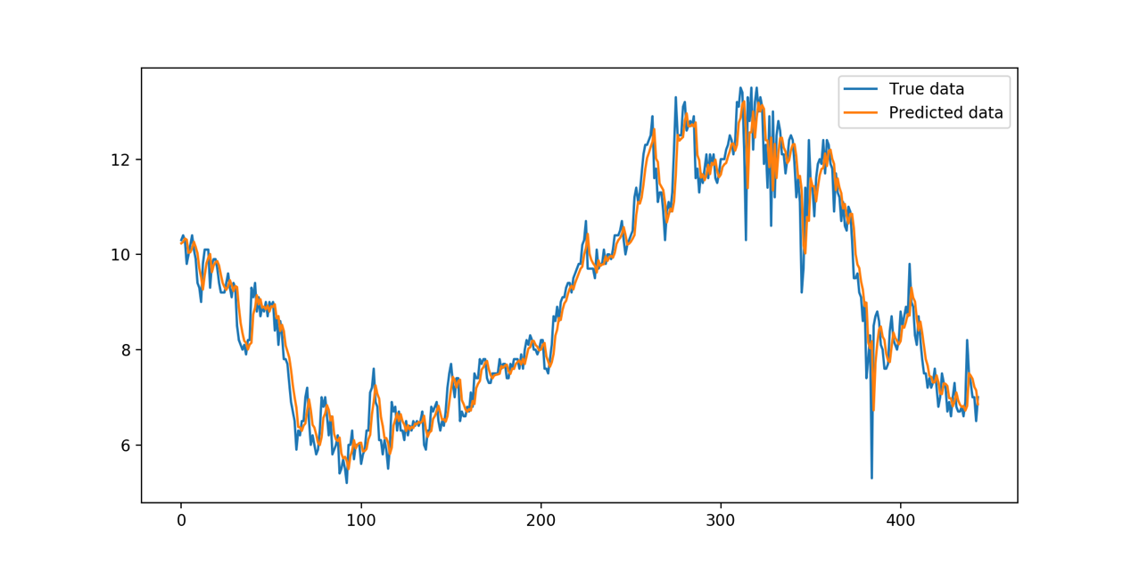

EEMD + BP

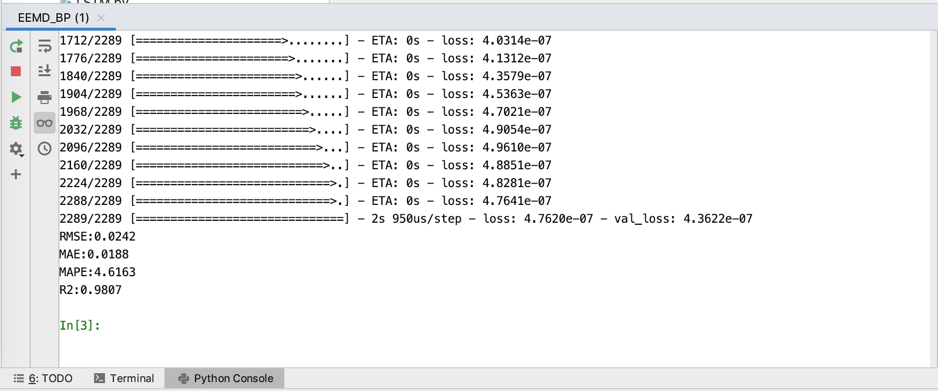

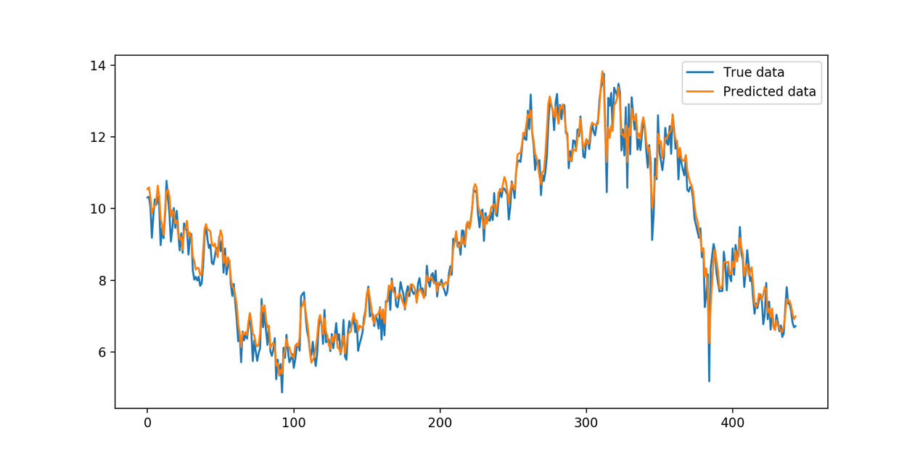RMSE:0.0242

MAE:0.0188

MAPE:4.6163

R2:0.9807

EEMD-LSTM

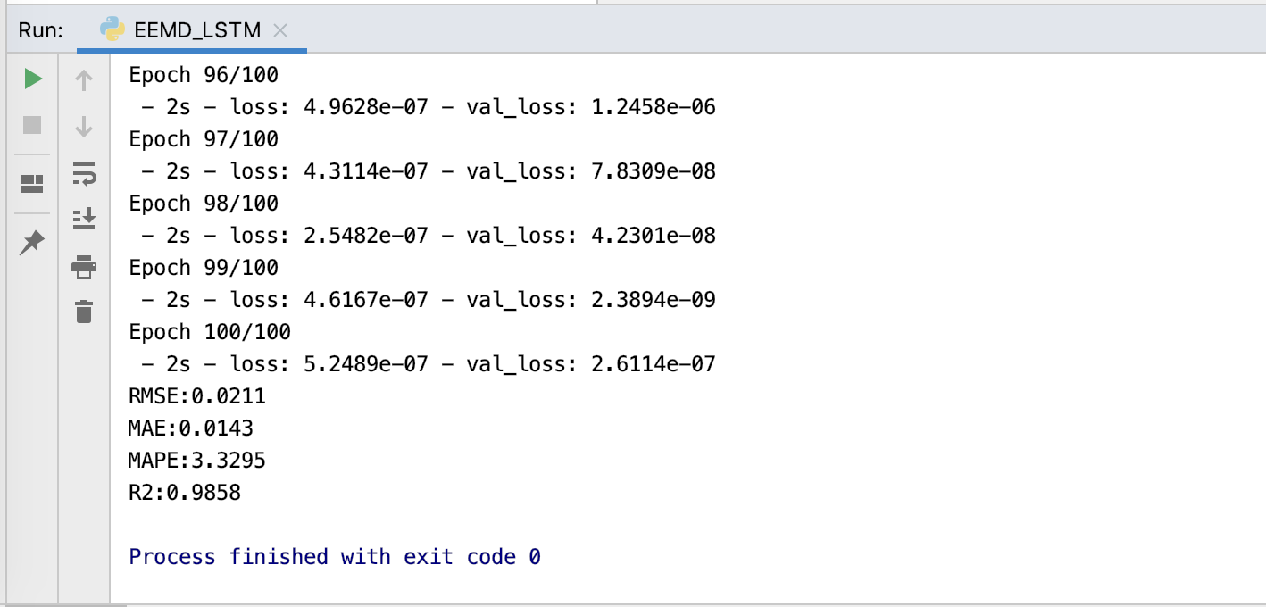

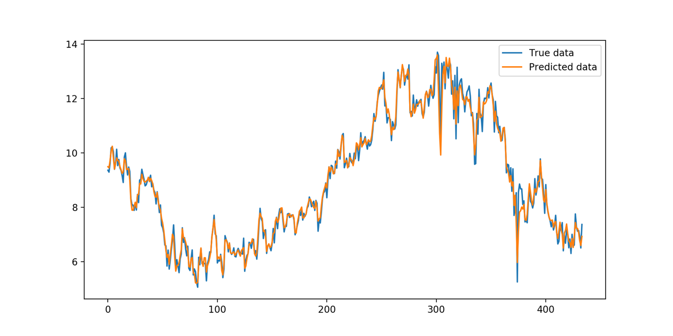RMSE:0.0211

MAE:0.0143

MAPE:3.3295

R2:0.9858